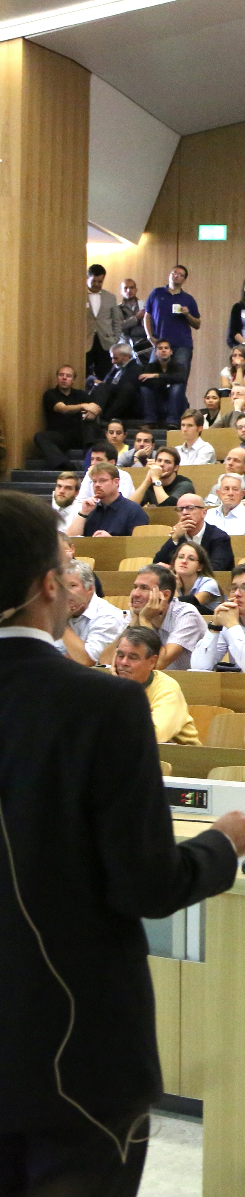
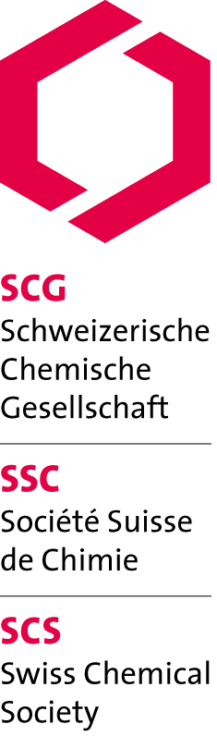

SCS Lectureships 2013

Prof. John Caradonna

Boston University (USA)

«Mechanism of action of non-heme iron metalloproteins, with a focus on the chemistry of metalloenzyme active sites involved in biological oxidation reactions»

Mon, 17.06.13, 16:15
University of Zurich, Anorganisch-chemisches Institut
Hörsaal 19, Winterthurerstr. 190, Uni Zürich Irchel'

http://www.scg.ch/scs-lectureships/
Supported by:
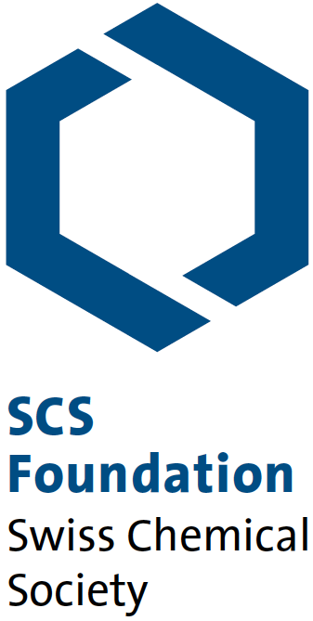

Swiss Chemical Society
Schwarztorstrasse 9
3007 Bern
www.scg.ch

