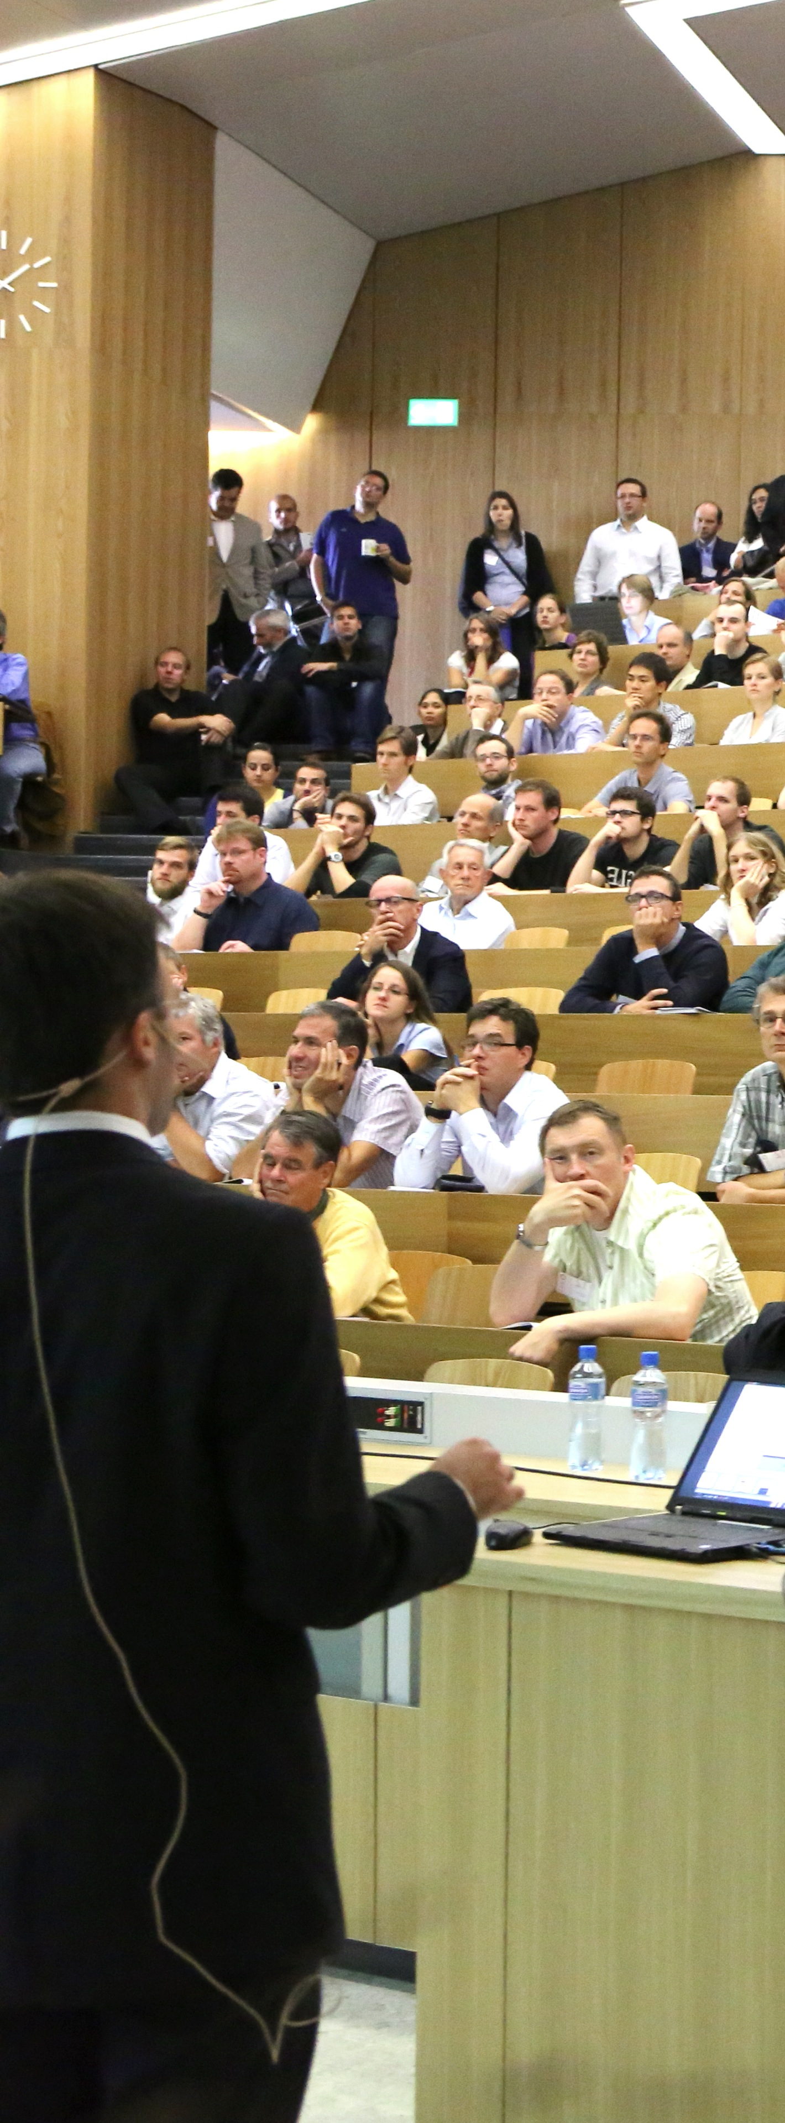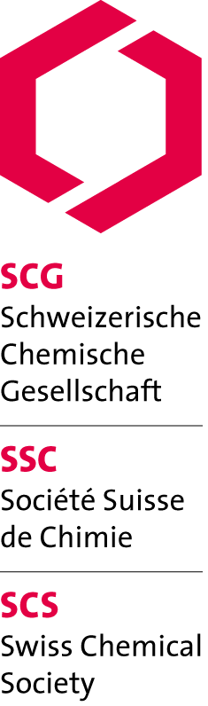

SCS Lectureships 2013

Prof. John Caradonna

Boston University (USA)

«Mechanism of action of non-heme iron metalloproteins, with a focus on the chemistry of metalloenzyme active sites involved in biological oxidation reactions»

*Mon, 17.06.13, 16:15*

University of Zurich, Anorganisch-chemisches Institut

Hörsaal 19, Winterthurerstr. 190, Uni Zürich Irchel'

*Tue, 18.06.13, 16:30*

University of Basel, Anorganische und Organische Chemie

Kleiner Hörsaal, St. Johanns-Ring 19, 4056 Basel'

*Wed, 19.06.13, 11:30*

University of Fribourg, Chemistry Department

Main auditorium, chemin du Musée 9, Fribourg

*Thu, 20.06.13, 17:00*

EPFL, Institut des Sciences et Ingénierie Chimiques

BCH 3118, 1015 Lausanne'

*Fri, 21.06.13, 11:00*

University of Genève, Chimie organique

Auditoire A-100, Sciences II, Quai Ernest-Ansermet 30, Genève'

http://www.scg.ch/scs-lectureships/

Supported by:

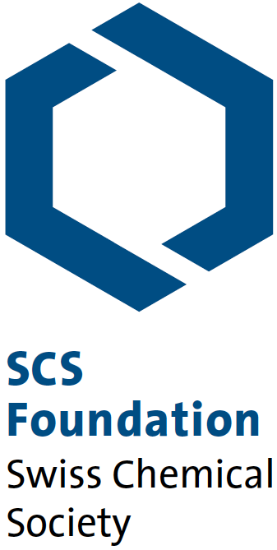

Swiss Chemical Society

Schwarztorstrasse 9

3007 Bern

www.scg.ch